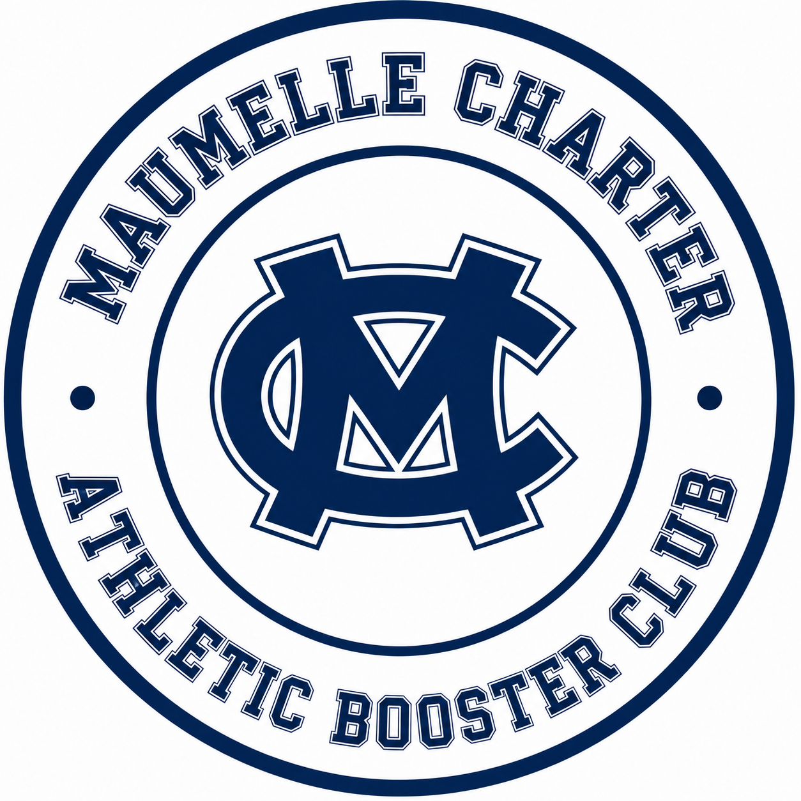

Booster Club Meeting
Aug 25, 2026

- Welcome
  - Introduce Board
  - Why We Got Involved
- Booster to Date
  - Our Mission
    - What we want to bring to Maumelle Charter.
  - What We Have Accomplished SO FAR
    - Coaches Gift
    - Camps Funded
    - Hudl Addition
    - Ballfrog MC Athletics App
    - Team Apparel and Warm-Ups
    - Covered cost of Senior Banners for all Senior Athletes, this has been historically charged.
- Concession Stand 2026-27
  - Staffing via Sign Up Genius and Funds Allocation
- Booster Club Apparel for 2026-27
  - Athletics Driven
  - Personalized Yard Signs
  - Announce Sales
- Golf Tournament Update
  - Need volunteers via sign up genius
  - Only a few teams left
  - Help adding sponsors
  - Goal for this years tournament, financial
- Financial Overview
  - Raised year to date
  - Financial goal for the year, through all Booster Channels
  - Sponsors Current vs Goal
- Membership
  - Current Count vs Goal
  - Why is membership important to MC?
- Questions……

- Adjourn

